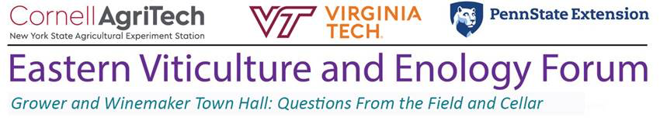

In collaboration with viticulture and enology extension programs at: Ohio State University, University of Maryland, Rutgers University, North Carolina State University, University of Georgia, University of Tennessee, Mississippi State University, Texas Tech, Texas A&M, Colorado State University, New Mexico State University, University of Nebraska, Iowa State University, Purdue University, University of Minnesota, Michigan State University, and University of Wisconsin
_____________________________________________________________________
Regional viticulture and enology specialists will present a Grower and Winemaker Town Hall virtual meeting series to give seasonal updates and answer pre-submitted and live questions from grape and wine industry stakeholders.

The structure of these meetings depends on pre-submitted questions. Use this link to pre-submit questions for viticulture and enology specialists to answer live during the meeting. Please feel free to submit questions related to any topic by July 6th. But please see below for the topic area suggestions for the July 13th meeting.

Viticulture focus area: post-fruit set to veraison (crop load management, canopy management, pest management, nutrient management, mechanization of vineyard operations)
Enology focus area: primary fermentation (harvest decisions, fruit chemistry analysis, and fermentation options, e.g. non-Saccharomyces yeast, strain selection, ambient ferments)

There will be a total of four town hall meetings throughout the growing season. Meetings will be held from 3PM to 5PM on the following Tuesdays: July 13th, August 10th, and September 7th. The first two meetings will be hosted by Cornell University and the second two meetings will be hosted by Penn State Extension.

Register using this link and choose your breakout room (viticulture or enology) for the July 13th meeting. After registering, you will receive a confirmation email containing information about joining the meeting.

-Cain Hickey, Beth Chang, and Tim Martinson
Eastern Viticulture and Enology Forum Hosts

