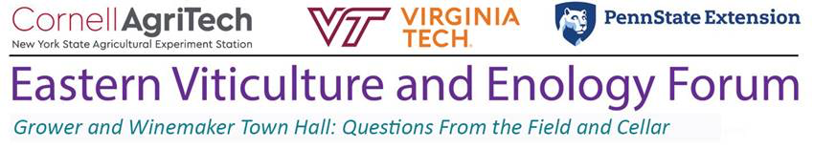

In collaboration with viticulture and enology extension programs at: Ohio State University, University of Maryland, Rutgers University, North Carolina State University, University of Georgia, University of Tennessee, Texas Tech, Texas A&M, Colorado State University, New Mexico State University, Iowa State University, Purdue University, University of Minnesota, Michigan State University, and University of Wisconsin
_____________________________________________________________________
Regional viticulture and enology specialists will present a Grower and Winemaker Town Hall virtual meeting series to give seasonal updates and answer pre-submitted and live questions from grape and wine industry stakeholders.

There will be a total of four town hall meetings throughout the growing season. Meetings will be held from 3PM to 5PM on the following Tuesdays: June 8th, July 13th, August 10th, and September 7th. The first two meetings will be hosted by Cornell University and the second two meetings will be hosted by Penn State Extension.

Use this link to register and choose your breakout room (viticulture or enology) for the June 8thmeeting.

The structure of these meetings depends on pre-submitted questions.
Use this link to pre-submit questions for viticulture and enology specialists to answer live during the meeting.

Please feel free to submit questions related to any topic by June 1st.
But please see below for the topic area suggestions for our first meeting on June 8th. Updated topic suggestions will follow in forthcoming meeting announcements.
Viticulture focus area: pre-bloom to post-fruit set management (canopy management, fruit zone leaf removal, nutrition, young vine establishment, fruit set, fungal disease management)
Enology focus area: filtration and bottling (types of filtration, filter pad maintenance & usage, pre-bottling sanitation, pre-bottling additions, bottling line cleanliness & quality controls)

-Cain Hickey, Beth Chang, and Tim Martinson
Eastern Viticulture and Enology Forum Hosts

