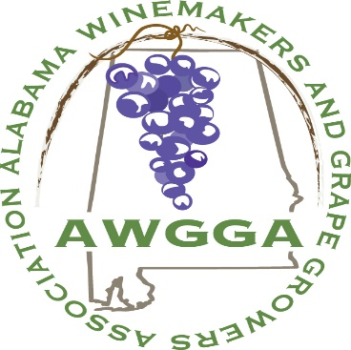  

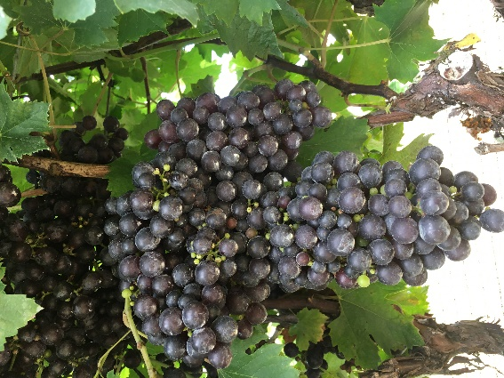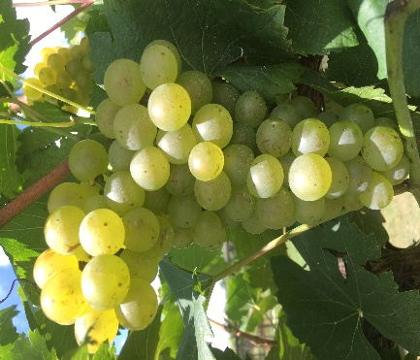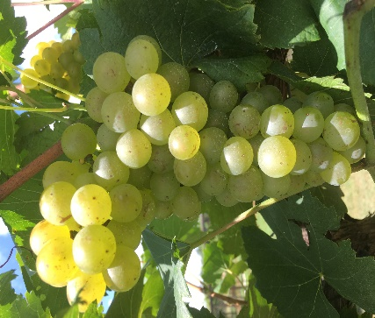

Please join us at

**THE 2019 AWGGA ANNUAL CONFERENCE**

Hosted by the AWGGA, the Alabama Cooperative Extension System, and Auburn University  
  
The Conference will take place on Sept. 13, 2019 at the Petals of the Past located at 16034 Co Rd 29, Jemison, AL 35085, <https://www.petalsfromthepast.com/>  
  
**AGENDA**  
**9:00 am -9:15 am**: AWGGA Vice President Becky Berta Welcome  
**9:15 am – 12:00 pm:**  Educational session  
  
The Keynote speaker Dr. Andrew Walker, UC Davis, CA will talk about “Pierce’s disease resistant European wine grapes nearing release from UC Davis”.  
  
Dr. Elina Coneva, Dr. Kassie Conner, Auburn University, Dr. Cain Hickey, University of Georgia, Mr. Randal Wilson, White Oak Vineyards, among other speakers will share experience cultivating UC Davis developed PD resistant European grapes in Alabama and the S.E.  
  
**12:00 am – 1:30 pm:** Lunch (Included with Registration)  
  
**1:30 pm – 1:45 pm:** Travel to the Chilton Research and Extension Center, located at 120 Co. Rd. 756 Clanton, AL 35045 <https://aaes.auburn.edu/regional-centers/>  
  
**1:45 pm - 3:00 pm:** Walking tour and demonstration of research vineyards where Dr. Walker’s  PD resistant *Vitis vinifera* (European) grapes are  being grown on different training stems

**3:00 pm:** Adjourn

**Please, register for the meeting by: September 6, 2019.  Tickets will be limited to the first 70 to register. Checks for $80 for AWGGA members and $90 for non-members may be mailed to Paul Downs, 214 Sanders Road SE, Hartselle, AL 35640 - please also reply here when you have registered.  In the alternative, you may use PayPal for an additional convenience fee (total PayPal cost $82.70 for members and $93.00 for non-members) at**[**paypal.me/AWGGA**](http://paypal.me/AWGGA)**<**[**http://paypal.me/AWGGA**](http://paypal.me/AWGGA)**>.  If you have questions, please contact Kim Miller at:**[**awggainfo@gmail.com**](mailto:awggainfo@gmail.com)**or (205) 515-0113 (text is best).  Also click "going" on our Facebook event.  We need to keep track so we do not run out of room!**