**Suggested Spray Schedule for Spring Disease Control in Strawberries**

*Bill Cline and Caleb Bollenbacher, NCSU*

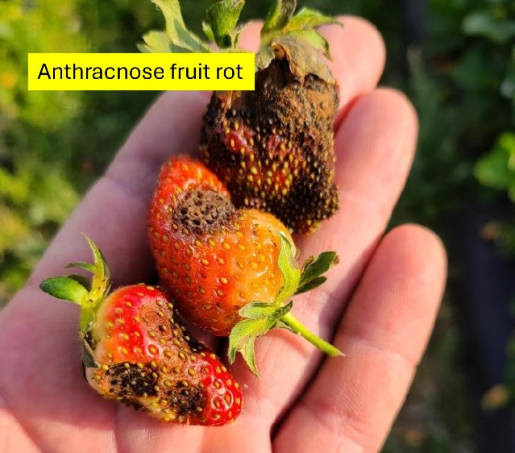The fungicides we use on strawberries are not all the same – some control several diseases, while others control only one. Some products are more susceptible to resistance development and are restricted by the number of times they can be used in a season. This makes it difficult to “stitch together” a spray program that controls diseases while also abiding by label restrictions.

Older protectant fungicides like Captan and Thiram have broad efficacy, can be used repeatedly, and have multiple modes of action, meaning resistance development is unlikely. In dry years with low disease pressure, protectants alone can provide sufficient disease control.

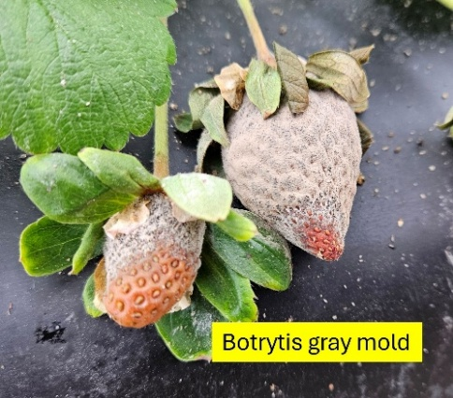Some fungicides target a single pest. Botryticides, for example, will only work against gray mold (*Botrytis*). These botrytis-only products include Elevate, Kenja, Fontelis, Scala, and others. Rovral is also a botryticide, but can only be used once, prior to “the first fruiting bloom”.

Newer, broad-spectrum or “pre-mixed” products are also available that combine two single mode of action fungicides. With more than one active ingredient, these products will reduce Botrytis gray mold, Anthracnose fruit rot, and in some cases will also help to control Neopestalotiopsis leaf and fruit rot (“Neo-P”).

When developing a spray schedule for your farm, it is important to rotate active ingredients to prevent resistance development and maximize long term control.

The table below is derived from an excellent presentation by Dr. Guido Schnabel in the 2021 strawberry webinar series at smallfruits.org. This is only one example and is not meant to exclude products – there are many more labeled products and combinations that could be used in a sequence of weekly sprays.

This sequence assumes that (i) sprays begin in March and the first pick date is in late March or early April, (ii) Botrytis is a cool-season disease and will be more severe in early weeks, (iii) anthracnose is a warm-season disease and will be more severe later in the season, (iv) the use of Thiram and Switch will be maximized to optimize Neo-P management and (v) there will be high disease pressure, i.e., rainy weather, in 2025 during harvest.

|  |  |  |  |  |  |
| --- | --- | --- | --- | --- | --- |
| **One possible sequence of fungicide sprays, considering use limits and rotation requirements for disease resistance management. Use caution with tank mixes, and when in doubt spray products separately rather than tank mixing. Adjuvants are not recommended. See product labels for rates and precautions.** | | | | | |
| **Week** | **2025 Dates (Monday-Saturday)** | **Fungicides (FRAC codes in parentheses)** | **Re-entry interval** | **Pre-harvest interval** | **Max # of applications**  **per season** |
| 1 | March 3-8 | Rovral (2) [must be used before the first fruiting flower has opened] | 24 hrs | 30+ days? | 1x |
| 2 | March 10-15 | Thiram (M3) or Captan (M4) +  Kenja (7) | 24 hrs  12 hrs | 24 hrs  0 day | 12x or 8x  Kenja 3x |
| 3 | March 17-22 | Thiram (M3) or Captan (M4) +  Kenja (7) | 24 hrs  12 hrs | 24 hrs  0 days | 12x or 8x  Kenja 3x |
| 4 | March 24-29 | Thiram (M3) or Captan (M4) +  Elevate (17) | 24 hrs  12 hrs | 24 hrs  0 days | 12x or 8x Elevate 2x |
| 5 | March 31-April 5 | Thiram (M3) or Captan (M4) +  Elevate (17) | 24 hrs  12 hrs | 24 hrs  0 days | 12x or 8x  Elevate 2x |
| 6 | April 7-12 | Inspire Super (3+9) | 12 hrs | 0 day | 4x |
| 7 | April 14-19 | Miravis Prime (7+12) | 12 hrs | 0 day | 2x |
| 8 | April 21-26 | Miravis Prime (7+12) | 12 hrs | 0 day | 2x |
| 9 | April 28-May 3 | Thiram (M3) or Captan (M4) | 24 hrs | 24 hrs | 12x or 8x |
| 10 | May 5-10 | Switch (9+12) | 12 hrs | 0 day | 2x |
| 11 | May 12-17 | Thiram (M3) or Captan (M4) | 24 hrs | 24 hrs | 12x or 8x |
| 12 | May 19-24 | Thiram (M3) or Captan (M4) | 24 hrs | 24 hrs | 12x or 8x |
| 13 | May 26-31 | Switch (9+12) | 12 hrs | 0 day | 2x |
| 14 | June 2-7 | Thiram (M3) or Captan (M4) | 24 hrs | 24 hrs | 12x or 8x |

Please let us know if you have any questions or spot any mistakes in this hypothetical spray plan! How different is this from your spray schedule? It is a challenge to configure a full-season spray schedule within the confines of current labeling. Hopefully you will find this helpful.