MANAGEMENT OF SORGHUM INSECT PESTS IN 2019
David Buntin, Grain Crop Entomologist, UGA-Griffin Campus (gbuntin@uga.edu)
Michael Toews, Crop Entomologist, UGA-Tifton Campus (mtoews@uga.edu)

Seed/Seedling Pests: Lesser cornstalk borer: Larva of a moth that feeds on and may kill seedling plants. It is favored by conventional tillage under hot, dry conditions, sandy soils, double-cropping behind cereal grains, and planting into burnt cereal grain stubble. Best control is at-planting use of chlorpyrifos (Lorsban, others). Seed treatments provide suppression. Rescue treatments, once damage is detected, often are ineffective.

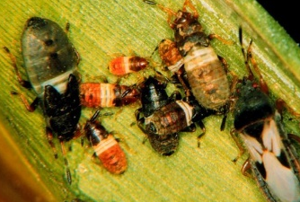
Chinch bugs: can infest sorghum at any stage, but is most damaging during the seedling
and early vegetative stages. Adults are about 1/8-inch-long, black with a white to silver
'X' marking on the back. Chinch bugs suck plant sap and feed mostly on the stem and
large leaf veins. Feeding causes red/yellow leaf discoloration, wilting and stunted
growth. Chinch bugs prefer hot dry conditions. Treat when 50% of plants are infested
OR five or more chinch bugs per plant are present.

Whorl worms usually fall armyworm: Sorghum is very tolerant of defoliation. Insecticide control seldom is justified. Treatment should be considered when 50% or more of the whorls are being damaged and larvae are present, OR one or more worms per whorl are present.

Sorghum midge: Sorghum midge is a tiny, fragile-looking, orange-colored gnat-like fly. Eggs are laid singly in sorghum flowers during pollination. The larva is an orange maggot that feeds on the developing seed. Early plantings often avoid serious midge infestations. Control of sorghum midge requires control of egg-laying adults. Sample 20 heads with a 1-gal plastic freezer bag for adult midges. Treatment threshold is one 1 adult per panicle (head) at about 25-30% bloom. Re-inspect fields within three (3) days and continue to sample until 90% bloom and re-treat if needed. Pyrethroid insecticides are very effective but may flare sugarcane aphid. Use Blackhawk or Chlorpyrifos (1 pint per are) for low to moderate infestations. Pyrethroids can be tank mixed with Sivanto prime (Do not use Transform WG during bloom).

Headworms: Usually Corn earworm, fall armyworm or sorghum webworm. Sample 25-50 heads over a bucket and count larvae. Treat if 1 or more larvae (1/2 inch or longer) are present or 5 or more webworms are present. Use Prevathon, Blackhawk, or Lannate for headworms. Beseige is a mix of Prevathon and lambda cyhalothrin.

Stink bugs on grain heads: Southern green, green and brown stink bugs. Also leaf-footed bugs. Treat if combined numbers of all stink bugs (large nymphs and adults) exceeds 3 bugs per head during milk stage or 6 bugs per head during soft dough stage.

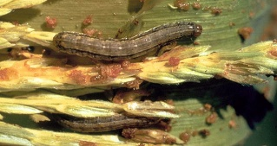
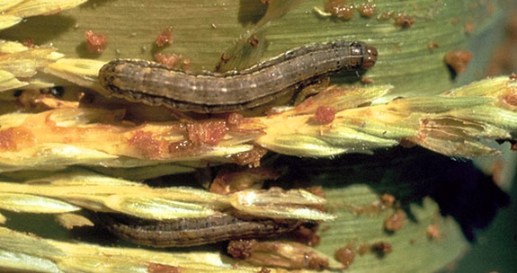
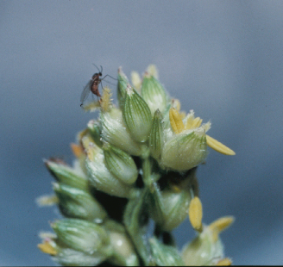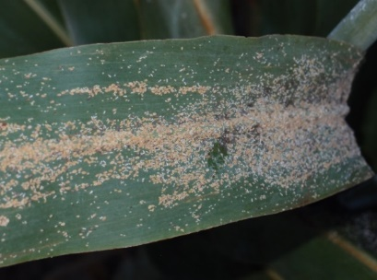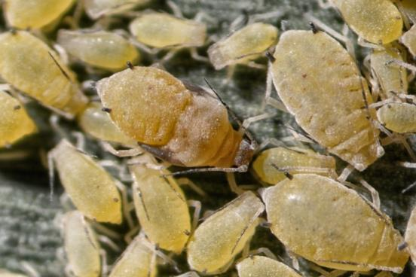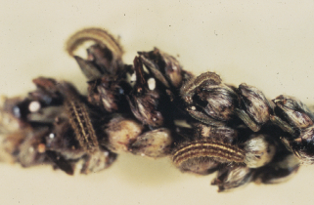
Photos (left to right): Sorghum midge, sugarcane aphid infestation and close up, sorghum webworm on grain head, and fall armyworm in whorl.

Management Practices for Sugarcane Aphid (SCA)
Plant early to avoid very large infestations before heading and grain fill.
Plant a tolerant Variety. Some hybrids have been shown to have tolerance and partial resistance to the aphid. But all tolerant variety may still have aphid infestations and need to be monitored and treated if infestations exceed treatment threshold listed below. Tolerant grain types are listed:
Company | Variety | Maturity | SCA Tolerance | Comment
Alta Seeds | AG1201 | Med-Early | Fair-Good
Alta Seeds | AG1203 | Med-Early | Good
Alta Seeds | ADV G3247 | Med-Early | Good
Dekalb | DKS 3707 | Medium | Good
Dekalb | DKS 2907 | Early | Fair-Good | Cream colored seed
Dyna-Gro | M74GB17 | Med-Full | Good
Dyna-Gro | M73GR55 | Med-Full | Good
Pioneer | 86P20 | Med-Full | Good
Pioneer | 83P17 | Med-Full | Fair
Sorghum Partners | SP73B12 | Med-Full | Good
Sorghum Partners | SP78M30 | Med-Full | Good
Sorghum Partners | SP7715 | Med-Full | Good
Warner | W-7051 | Full | Good | Tall

An insecticide seed treatment limits seedling infestations for 30 – 35 days after planting. All registered neonicotinoid insecticides are effective; thiamethoxam (Cruiser), clothianidin (Poncho, NIpsIt Inside), and imidacloprid (Gaucho, others). Most useful on susceptible hybrids planted late.
Scout early and treat when aphids reach threshold levels. The current threshold is 50 or more aphids per leaf on 25% pf plants preboot stage through dough stage. Once threshold is reach do not delay application because infestations can increase very quickly
Use an effective insecticide. PYRETHROID INSECTICIDES ARE NOT EFFECTIVE and may flare infestations by killing all the aphid predators. Foliar insecticide options for SCA in Georgia are:
- Sivanto prime (Bayer Crop Protection) @ 4 to 10 fl. oz. per acre. Sivanto prime at 4-5 fl. oz. provides control usually lasting 21 days or more. PHI = 21 days.
- Transform WG (Dow AgroSciences) @ 0.75 to 1.5 oz. per acre. 2 applications per season. PHI = 14 days. Use rates of 1.0 and 1.5 oz. per acre, but use the 1.5 oz. rate if aphid populations are increasing rapidly. A Section 18 emergency exception has been requested for Transform WG use on sorghum in Georgia in 201(. Transform cannot be used during bloom.
- Chlorpyrifos (Lorsban Advanced, Nufos, other) @ 1-2 pint per acre. Use 2-pint rate which gives 60-90% control for about 7-10 days. At the 2 pint rate it cannot be used after the boot stage due PHI = 60 days.
DO NOT USE CHLORPYRIFOS ON SWEET SORGHUM.
Good coverage is important for effective control. Use tips and GPA for maximum coverage especially lower in the canopy. A minimum of 10 gpa by ground and 5 gpa by air is highly recommended.
Check fields before harvest for infestations. A treatment may be needed if large numbers are in the head to prevent interference with harvest and damage to combines. Transform WG can be applied up to 14 days before harvest.
Silage/forage sorghum control. Currently we are using similar recommendations for silage and forage sorghum as for grain sorghum. Only a small number of forage/silage types have some tolerance to SCA as summarized by Dr. Dennis Hancock (UGA forage agronomist) (next table) : http://www.caes.uga.edu/extension-outreach/commodities/forages/species-and-varieties/warm-season/sorghums.html
Both Sivanto prime and Transform can be used on silage and forage type sorghums. Grazing / hay interval is 7 days for both products. Spray coverage is difficult when plants get tall. If aphids are present but below threshold consider a spray application as late as possible before the crop gets too tall.
Sweet sorghum. Transform WG and chlorpyrifos cannot be used on sweet sorghum. A Section 18 label has been requested for use of Sivanto prime on sweet sorghum in Georgia in 2019.

Variety comparison among noteworthy sorghum x sudangrass hybrids. 2018.ª
Varietyª | Region^{b} | Yields^{c} | SCA Tolerance^{d} | Company | Com-ments^{e}
AS5201 | S | good | poor | Alta Seeds | 3
AS6401 | P | good | poor | Alta Seeds | 3
AS6402 | P | good | poor | Alta Seeds | 3
DSM 33-948 | CP | good | good | Desert Sun | 2
FullGraze BMR | CP | good | good | Dyna-Gro | 1
SDH 2942BMR | P | good | poor | Sorghum Partners | 3
Southern Star | CP | good | v. good | Meherrin Ag | 1
SOUTHERN SWEET | CP | fair | good | Meherrin Ag | 2
SP6205 BD | CP | good | good | Sorghum Partners | 2
SS-220BMR | S | good | poor | Southern States | 3
Super Sugar | S | good | good | Gayland Ward | 3
Sweet Six BMR Dry Stalk | S | good | poor | Gayland Ward | 3
XtraGraze BMR | P | good | good | Coffey | 3
- ª Bolded varieties meet the yield performance criteria yields greater than average for 3 yrs in the Statewide Variety Testing program) to be recommended by UGA and have at least a good tolerance to the sugarcane aphid (SCA).
- ^{b} Region where recommended where P = Piedmont and Mountains, CP = Coastal Plain, and S = Statewide.
- ^{c} Yield ratings where good = average or above, fair = below average. Poor yielding varieties are not listed.
- ^{d} Ratings for resistance to sugarcane aphid damage where poor = no resistance, good = moderate resistance, very good = resistant, and excellent = highly resistant.
- ^{e} Number of years the variety was included in the Statewide Variety Testing program’s summer annual forage trial. 1 = 1 year; 2 = 2 years; and 3 = 3 or more years. More info on UGA's Statewide Variety Testing page (see: Soybean, Sorghum Grain & Silage, Summer Annual Forages & Sunflower Performance Tests)

